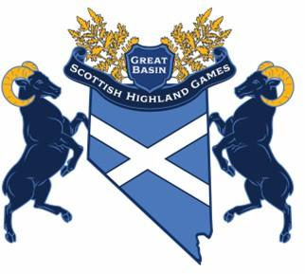
Games Sponsorship September 13th and 14th, 2025
Suggested sponsorship levels for the 2025 Great Basin Scottish Highland Games:
William Wallace level $1500 and above
Robert the Bruce level $1000 - $1499
Mary Queen of Scots level $600 - $999
Rob Roy level $250 - $599
Robert Burns level $25 - $250
Loch Ness level In kind donation

All sponsorship includes the following:
Admission for 2 to the Great Basin Scottish Highland Games (both days)
-Parking for 1 vehicle
-Your company banner displayed at the arena
-Marketing shouts outs during the games
-Logo added to our social media sites
Company Name/Contact Name: _____________________________________________________________
Address: ___________________________________________________________________________________
Email: _____________________________________________________________________________________
Phone: _____________________________________________________________________________________

Mission Statement: To promote a cultural, family friendly experience for our community in Northern Nevada by providing an affordable and traditional Scottish Highland Games organized by athletes for athletes.
Values: Preservation, Promotion, Fraternity, Future, Community.

The Great Basin Scottish Highland Games is honored to support the following community partners:
- The Altruistic American: Raises awareness of mental health issues. (In kind partnership)
- The Reed High School Sea Cadets-provide parking for the Great Basin Scottish Highland Games. All parking proceeds go to their program.
- Nevada Society of Scottish Clans- (in kind partnership)
- For the 2025 Great Basin Scottish Highland Games, The Nevada Veterans Foundation has been selected for our support. A portion of our proceeds will go to this amazing community organization.

Make donation checks to:
Northern Nevada Throwing Company
PO Box 61685
Reno, NV 89506
We are a 501(c)(3) organization. Contributions are tax deductible as allowed by law.
Federal ID number 84-4970195

